# IoT based Health Monitoring System

**Prof. Dhotre V.A.**

# CSE Department, SKN SCOE, Solapur University

**Mr.Kadam S.B., Mr.Mane Y.L., Mane Y.H., Mr.Kore S.S.**

*Abstract— Health has prime an incentive in our everyday life. Sound health is compulsory to do the day by day work appropriately. This task goes for building up a framework which gives body temperature and pulse utilizing LM35 and heartbeat sensor separately. These sensors are obliging with controller Arduino UNO board. Remote information transmission done by Arduino through wifi module.ESP8266 is utilized for remote information transmission on IoT stage for example thing speaks. Information representation is done on Thing speak. So that record of data can be stored over period of time. This information put away on web server with the goal that it can see to who logged.*

***Keywords- Health, controller, pulse sensor, temperature sensor, IOT.***

### INTRODUCTION

With an enhancement in innovation of sensors, there have been endeavors to utilize the new innovation in various regions to improve the nature of human life.

One primary territory of research that has seen a reception of the innovation is the human services zone. The general population needing medicinal services administrations think that its over the top expensive this is particularly valid in creating countries. As an outcome, this task is an endeavor to tackle a human services issue, presently all individuals on the planet is facing. The principle objective of the undertaking was to structure a remote social insurance framework.

The Web of Things (IoT) thoughts have been broadly used to interconnect the accessible medicinal significant supplies and offer shrewd, solid, and successful human services administration to the patients. Health managing for dynamic and helped living is one of the mindsets that can utilize the IoT favorable circumstances to improve the patient's method for living.

We will make an IoT based Wellbeing directing Framework which records the patient heart beat rate and body temperature and furthermore send an email/SMS alert at whatever point those readings goes past basic qualities. Heartbeat rate and body temperature readings are recorded over ThingSpeak and Google sheets with

the goal that tolerant wellbeing can be directed from anyplace on the planet over web. A frenzy will likewise be appended with the goal that patient can squeeze it on crisis to send email/sms to their relatives.

1. **LITERATURE REVIEW:**

Modern health care system introduces new technologies like wearable devices or cloud of things. It provides flexibility in terms of recording patients watched/supervised data and send itremotely via IOT. For this connection, there is need of secure data transmission .To transmit the data with privacy is the Moto of this paper. The cloud server can share withverified user as per request. A patient with wearable devices constantly updates his record every5 or 10 min. In emergency mode, it updates for every 1min.The wireless device will send resultsto phone using Bluetooth connection or NFC technology. This can able to give to cloud serverusing GSM and 3G.

At cloud server, each patient is defines with unique address. So data at cloud can authenticate the right patient and provide the required request.

1. **SYSTEM ARCHITECTURE**

With an enhancement in technology of sensors, there has been triesto use the new technologyin different areas to improve the quality of human life. One main area of research that has seenan adoption of the technology is the healthcare part/area. The people in need of healthcareservices find it very expensive this is especially true in developing countries. HealthWatching/supervising System which records the patient heart beat rate and body temperatureand also send an email/SMS alert whenever those readings goes beyond critical values. Thesystem (related to the beautiful design and construction of buildings, etc.)s are shown below.

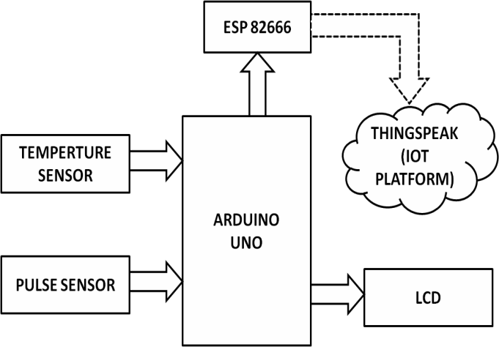

Fig. Flow of Health Monitoring System

1. **Temperature Sensor:**
2. **Pulse Sensor:**

The working of the **Pulse/Heart beat sensor** is very simple. The sensor has two sides, on one side the LED is placed along with an ambient light sensor and on the other side we have some circuitry. This circuitry is responsible for the amplification and noise cancellation work. The LED on the front side of the sensor is placed over a vein in our human body. This can either be your Finger tip or you ear tips, but it should be placed directly on top of a vein. Pulse Sensor is a plug-and-play heart-rate sensor for Arduino compatibles. It can be used by students, artists, athletes, makers, and game & mobile developers who want to easily incorporate live heart-rate data into their projects. e pulse readings.

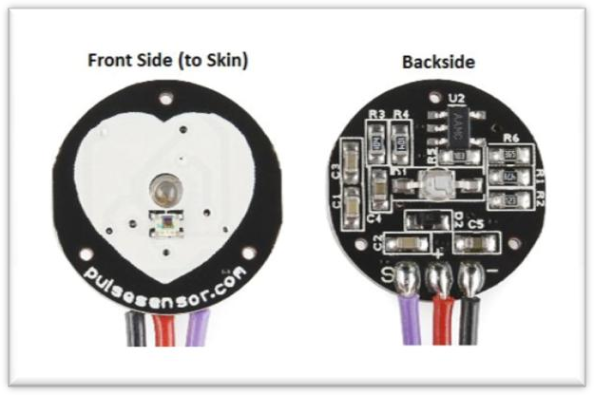

Temperature sensor is a device which is designed specifically to measure the temperature of a human body. LM35 is a high quality IC temperature sensor with its output (fair in amount, related to/properly sized, related to)the temperature (in Ã‚ Â°C). With LM35, the temperature can be measured more (in a way that's close to the truth or true number) than with (device that changes resistance as temperature changes). It also possesses low self-heating and does not cause more than 0.1 Ã‚ Â°C temperature rise in still air. The operating temperature range is from -55Ã‚ Â°C to

1. **Wi-Fi Module:**

Fig. Pulse Sensor

150Ã‚ Â°C The LM35's low output impedance, linear output, and exact built-in (a (change to make better/related to changing something) for (quality of being very close to the truth or true number)) make connecting/communicating to readout or control circuitry especially easy.

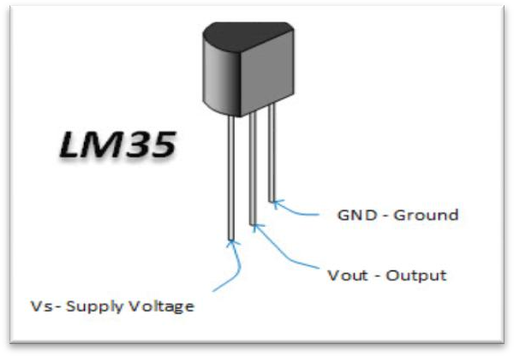

Fig. Tempareture Sensor

Commonly human body temperature, also known as normothermia or euthermia, is the typical temperature range found in humans. The usual human body temperature range is usually stated as 36.5-37.5 Â°C (97.7-99.5 Â°F).

The objective of this post is to explain how to get some information about the flash chip of an ESP8266 board, using the Arduino IDE libraries functions. To do so, we will use the methods available [here](https://github.com/esp8266/Arduino/blob/master/cores/esp8266/Esp.cpp), which are exposed in a class called [EspClass](https://github.com/esp8266/Arduino/blob/master/cores/esp8266/Esp.cpp#L197).

As we can see in the [header file](https://github.com/esp8266/Arduino/blob/master/cores/esp8266/Esp.h) for the class, these are ESP8266 specific APIs, which expose some core functionality. Also, we can see in the same file that an extern variable called ESP, of class EspClass, is declared, so we can access it in our code.

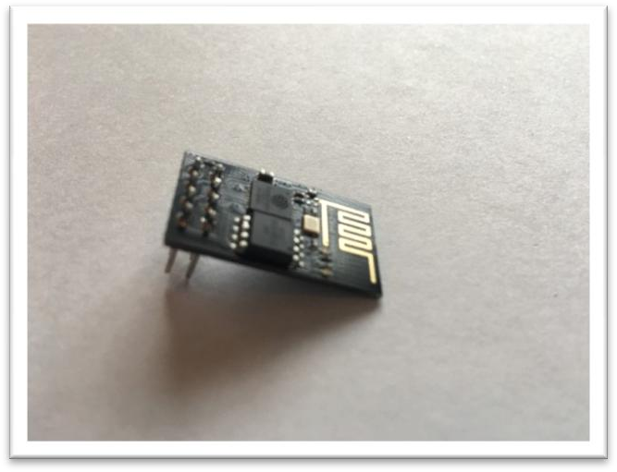

Fig. Wi-Fi Module

Using the SPI bus, Arduino communicates with the Wi- Fi shield. 11, 12, and 13 are the pins on the Uno and pins 50, 51, and 52 on the Mega. Pin 10 is used as SS on both boards. On the Mega, the hardware SS pin, 53, is not used but it must be kept as an output. Digital pin 7 is used as a handshake pin between the Wi-Fi shield and the Arduino, and should not be used. The Wi-Fi library and Ethernet library are very similar, and many of the function calls are the same.

## AURDINO UNO:

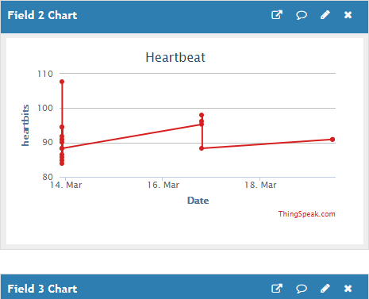Arduino is an open-source electronics platform based on easy-to-use hardwar and software. Arduino boards are able to read inputs from light on a sensor, a finger on a button, or a Twitter message, and this inputs turn into an output like activating a motor, turning on an LED, publishing something online. You can tell your board what to do by sending a set of instructions to the micro controller on the board.

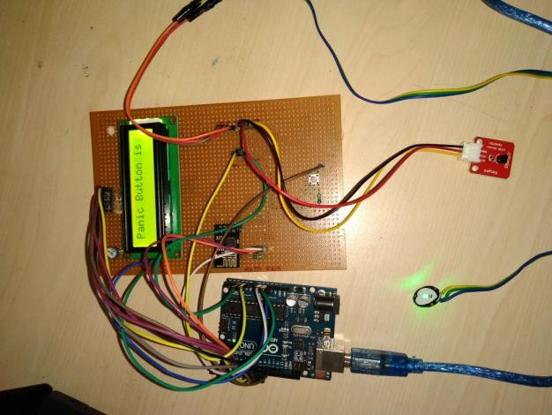

Fig. Setup of System

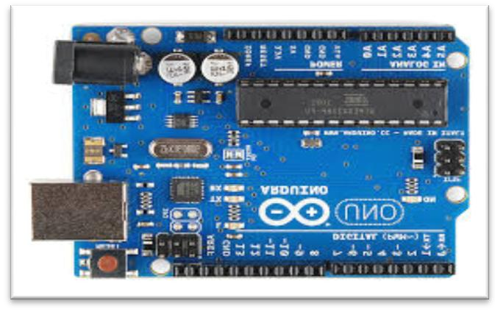

Fig. Arduino Uno UNO

Fig. Graph of Heartbeat

To do so you use the Arduino programming language based on Wiring, and the Arduino Software (IDE), based on Processing. All Arduino boards are completely open-source.and authorize users to build them independently and Use them to their particular needs.

1. **IMPLEMENTATION**

Use the ThingSpeak platform to send data to the cloud from any Internet-enabled device.

You can then configure actions and alerts based on your real-time data and unlock the value of your data through visual tools.

Use the Think speak offers a platform for developers that enable them to easily capture sensors data and turn it into useful information.

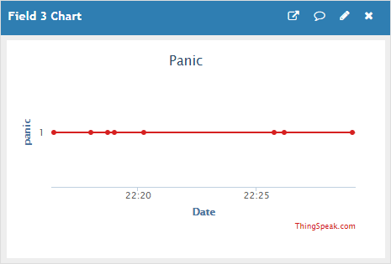

Fig. Graph of Panic

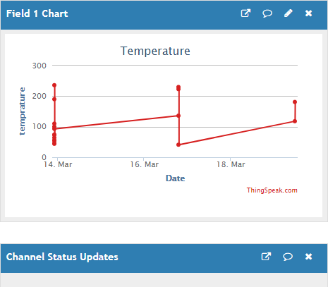

Fig. Graph of Temperature

### CONCLUSION

In this system we have implemented a Health Monitoring System to calculate Pulse rate and body temperature. Send Emergency message to doctor or relatives. It saves time and Money.

The main objective of the experiment was profitably accomplished. All the individual modules like Pulse detection module, fall detection module etc. and remote viewing module gave out the intended results.

### REFERENCES

* 1. Ebrahim Al Alkeem1, Dina Shehada1, Chan Yeob Yeun1,M. Jamal Zemerly ,Jiankun Hu “New secure healthcare system using cloud of things”, Springer Science+Business Media New York 2017.
  2. Yena Kim, SeungSeob Lee and SuKyoung Lee “Coexistence of ZigBee-based WBAN and WiFi for Health Telemonitoring Systems”, DOI 10.1109/JBHI. 2014.2387867, IEEE Journal of Biomedical and Health Informatics
  3. Mirza Mansoor Baig & Hamid Gholamhosseini “Smart Health Monitoring Systems: An Overview of Design and Modeling”, Springer Science+Business Media.
  4. S. M. Riazul islam, Daehan kwak, MD. Humaunkabir, Mahmud hossain, and Kyung-sup kwak,” The Internet of Things for Health Care:AComprehensive Survey” , DOI 10.1109/TDSC. .2015.240669 IEEE Transaction.
  5. Afef Mdhaffar, Tarak Chaari , Kaouthar

Larbi, Mohamed Jmaiel and Bernd Freisleben “IoT-based Health Monitoring via LoRaWAN”, IEEE EUROCON 2017

* 1. Mohammad M. Masud, Mohamed Adel Serhani, and Alramzana Nujum Navaz “Resource-Aware Mobile- Based Health Monitoring”,2168-2194 (c) 2015 IEEE
  2. Bansal , Ayush Sunil Kumar, Anurag Bajpai, Vijay N. Tiwari, Mithun Nayak, Shankar Venkatesan, Rangavittal Narayanan, “Remote health monitoring system for detecting cardiac disorders”, IET Syst. Biol., 2015, Vol. 9, Iss. 6, pp.3098- 314.
  3. Hamid Al-Hamadi and Ing-Ray Chen, “Trust-Based Decision Making for Health IoT Systems” DOI 10.1109/JIOT.2017.2736446, IEEE Internet of Things Journal.
  4. Muthuraman Thangaraj Pichaiah Punitha Ponmalar Subramanian Anuradha, “Internet Of Things (IOT) Enabled Smart Autonomous Hospital Management System

– A Real World Health Care Use Case with the Technology Drivers”, 2015 IEEE International Conference on Computational Intelligence and Computing Research.

* 1. Maradugu Anil Kumar, Y.Ravi Sekhar, “Android Based Health Care Monitoring System” IEEE Sponsored 2nd International Conference on Innovations in Information Embedded and Communication Systems ICIIECS'1.